Fun-Filled Fitness
Western Oregon Crew
Adam Hastings, Sean Kubishta, Kyle Kuust, Justin Larson,
Ali Reck, Annie Storey, Ashley Taylor, and Jessica Westby and Gay Timken

Fitness Parcheesi
Arrange polyspots in circle/square with an exercise/task under each spot. Students stand on or in front of one polyspot. Roll the dice. Add the number and everyone moves up that number of spots, gets the task card from under the spot and completes that exercise until the next roll.

Bingo Fitness
Prior to the lesson beginning lay task cards and dry-erase pens around the perimeter of the gym. Have each students choose their own task card and write his/her name on it. If the class size exceeds the amount of task cards, have students share the cards with a partner. Also set up 6 cones to create an area for students to run around.

Students will begin activity by select and writing their names on their own card. After students have their own cards they will begin jogging around the 6 cones for one minute. After a minute is up, the students will go back over to their board. The teacher will select what exercise students will be performing, using the decide now APP. They will mark the letter “X” through that specific exercise on their board and then perform the appointed skill for 20 seconds. After the 20 seconds is up, students will begin jogging around the cones again. This process will be repeated until a student or students get a bingo.

Continuous Relay

Students will be organized in groups of three. Two of the students in each group will line up together along Side A of the gym space, and the remaining student in each group will stand directly across from their group on Side B. One student from Side A begins the continuous relay by performing the first locomotor skill across the space to Side B, and simultaneously both students remaining on either side will perform the first exercise listed on their respective task cards. Once the student performing the locomotor skill arrives to Side B he/she will trade places with the student who was already at Side B by beginning the first exercise listed on the task card, while the student originally at Side B will perform the first locomotor skill across to Side A. Students will continue this relay until everyone has completed all exercises on the task cards. In essence, one student is always moving in the middle between the two students on opposite sides of the gym. Sample exercises for this activity

Outsides or “book ends”: Inside Locomotor movement:

Supermans Galloping
Plank Skipping
Jumping Jacks Fast walk
Crunches Grapevine
Squats Jog
Push-ups Bear Crawl
Jump rope Hop (alternating feet every 3 hops)
Choice Choice

Fitness Scavenger Hunt
Students in pairs or groups of three to work together to complete the Fitness Scavenger Hunt. Students start at number 1 and continue through the list and complete the task as a team. They can repeat if necessary.

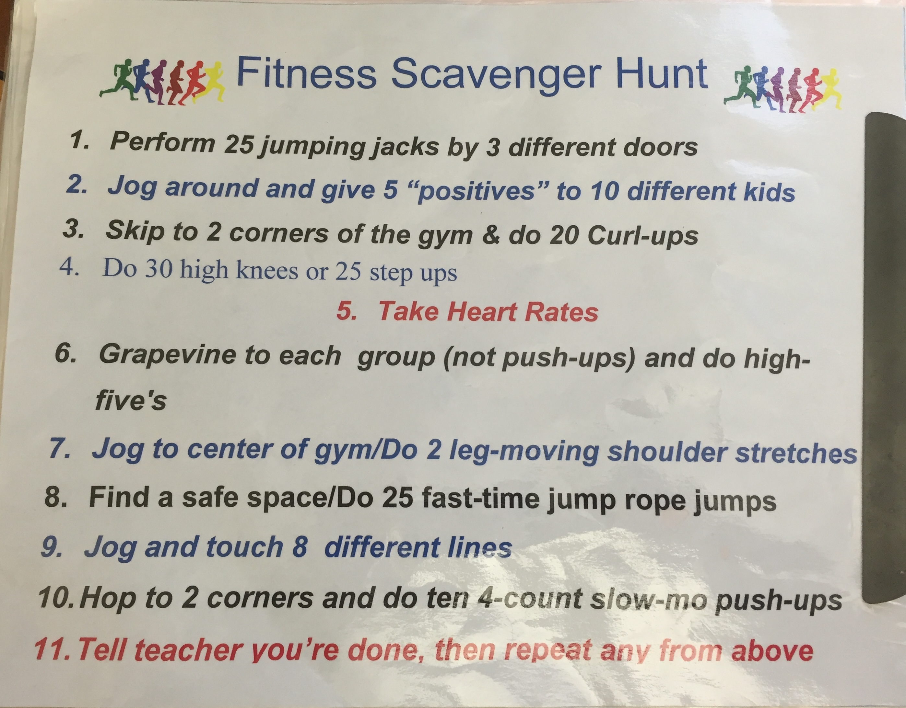

Race Track Fitness

At least 4 cones are set up to create a boundary for the ‘racetrack’ and the inside. Students have a partner; one partner begins on the inside, the other on the outside racetrack. At each cone there will be two cards, one for aerobic activities on the racetrack and the other for muscular strength/endurance or flexibility activities to complete on the inside of the track. Student’s work with a partner and start at a ‘home’ cone. While partner #1 is performing an aerobic activity around the perimeter (i.e., jogging, skipping, carioca), partner #2 is on the inside of the perimeter doing a stationary activity (i.e., crunches, pushups, dips). When partner #1 completes 2 laps around the perimeter and gets back “home”, they high five partner #2 and switch places. Partner #2 will do an aerobic activity on the outside of the perimeter while partner #1 is on the inside doing a stationary activity. Once both partners have completed the first activity on the cards they move on to the second activity and so on. Continuous music will be playing throughout the activity. Goal is to cover differences between muscular strength/endurance and cardio respiratory endurance.

-Variations in layout is have students perform MS/FLEX exercises in middle section of cones and have runners running around cones placed in square
-Teacher cues students to switch from inside to outside/ varies the movement (run, skip, slide, shuffle etc) instead of having it be partner 5-five based- makes it easier to watch form for MS/FLEX exercises

Examples for task cards for muscular strength/endurance and flexibility activities:
- Superman
- Plank
- Push-up
- Crab-cross touch or dips
- Figure 4 stretch
- Choice

Task cards for aerobic activities:
- Jog
- Skip
- Power walk
- Backwards jog
- Choice
- Slide (switch sides for 2nd lap)

Snack Attack
The purpose of the snack attack game is for students to get an understanding of calories in versus calories out. Calories in are represented as the snack in this game and the calories out are represented by different exercises or activities. As an example, if there is a snickers wrapper on a sheet, the sheet will list out a few different exercises and how long a person would have to do those activities in order to burn all the calories off from that snickers bar.

The students will be partnered up and once they have their partner they will go around to different stations where the snack attack cards will be located. On the cards it will mention the amount of calories of the food or drink and the amount of time it would take to burn off those calories while performing a certain activity. Under that, there will be that activity or exercise labeled for the students to do but obviously not for the amount of time that it would actually take to burn off that food or drink.

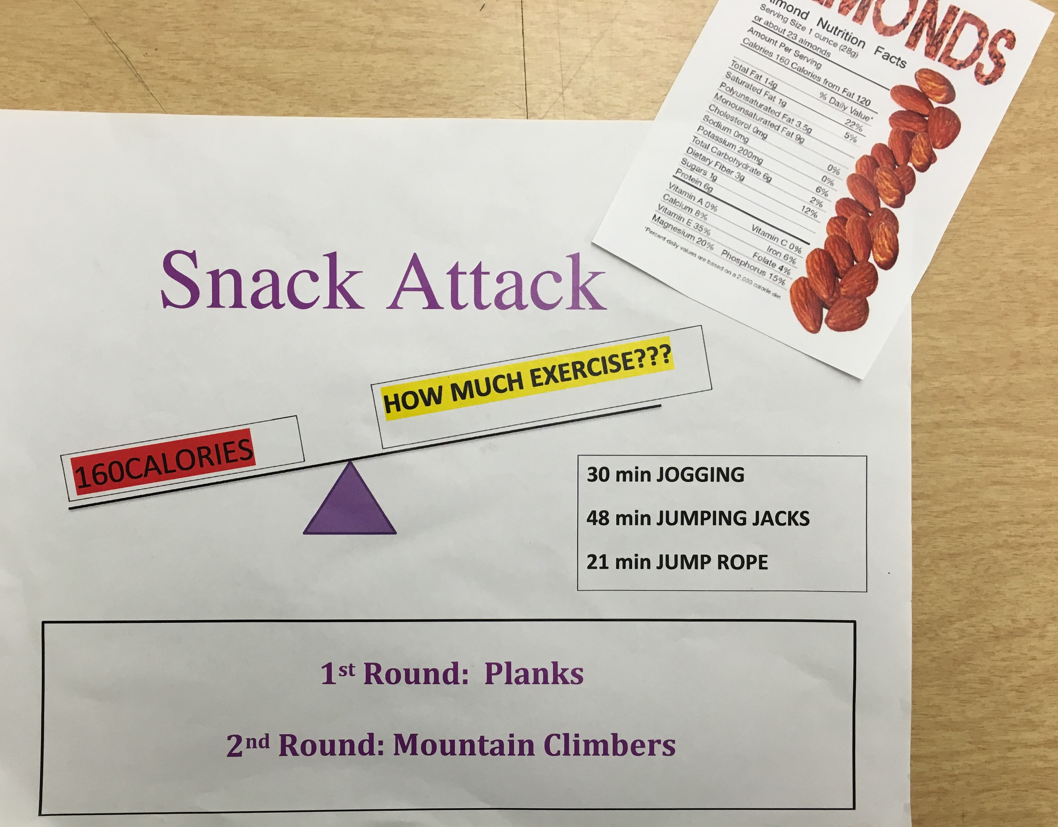

Dice Fitness
In small groups (2-4), students have one task card and two dice. They roll both and the total number matches the task on the task card. Simple and easy and kids enjoy the autonomy.

Alphabet Fitness
Students work individually. There are 26 cards and each card has a letter of the alphabet on it along with a physical activity (or a few) that goes with it. Exercises would include upper body, lower body, core, aerobic, explosive moves, and flexibility. The cards will be spread out randomly throughout the gym. Ask students to spell out their first and last name by going to each card and doing that exercise. Students could be asked to spell other words such as; fitness, heart, fair play, effort, safe space, etc. When they finish one letter they jog around until they find the next letter and do that activity.

High 5 Fitness

This will get the ol’ heart rate up! A blast and even the young kids can do this. Divide the class in half, both groups on opposing sides or ends of the gym. Each student should have a partner and be across the gym from their partner. Here’s how it goes.
Run to your partner (meet half-way) and give a R high five, then run back.
Run to your partner and give a R and then L high five, then run back.
(The run to your partner, half-way, then high 5, then run back is a
continual theme here, so I’ll be more brief from now on. The other part of this is that you keep adding on to the previous activity.)
R high five, L high five, R low five
R high five, L high five, R low five, L low five (and so on)
Double high five
Double low five
Double high five but back to back with partner
Double low five between legs but back to back with partner
R high five with R foot while seated
L high five with L foot while seated
Double high five with both feet while seated
R high five from pushup position
L high five from pushup position
Double high five from pushup position (might not be too safe to use for most groups)

You may need to give reminders of each high 5 activity during the much-needed break after each run back to home position.

